DESARROLLOS LAICON

> Elements

> Manage Infrastructure Elements Elements Envio Liza

> Delete Infrastructure Elements by File Elements **Pendiente**

> Unsuscribe Elements Elements **Pendiente**

> Upload Nonexistent Elements Elements **Pendiente**

> Upload Existing Elements Elements **Pendiente**

> Elements Editor

> Elements Multiple Editor from XLSX Elements **OK**

> Import Declarations

> Import Declaration Massive Update Elements OK

> Change State by Excel Elements

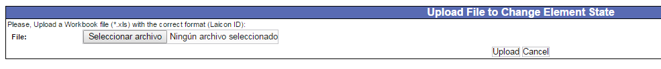

> Massively Update Material Master Valorization Locations



> Field Service Update Inventory

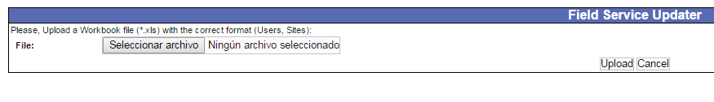

OK

> Upload Inventory File for Location Element Order **Pendiente**

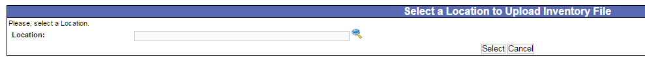



> Admin. Massive Destination Change ATN Elements Inventory OK

> Upload SISCAP **Pendiente**

> Capitalize Elements from Workbook Crossing Process **Pendiente**

> Upload Crossing Elements **Pendiente**